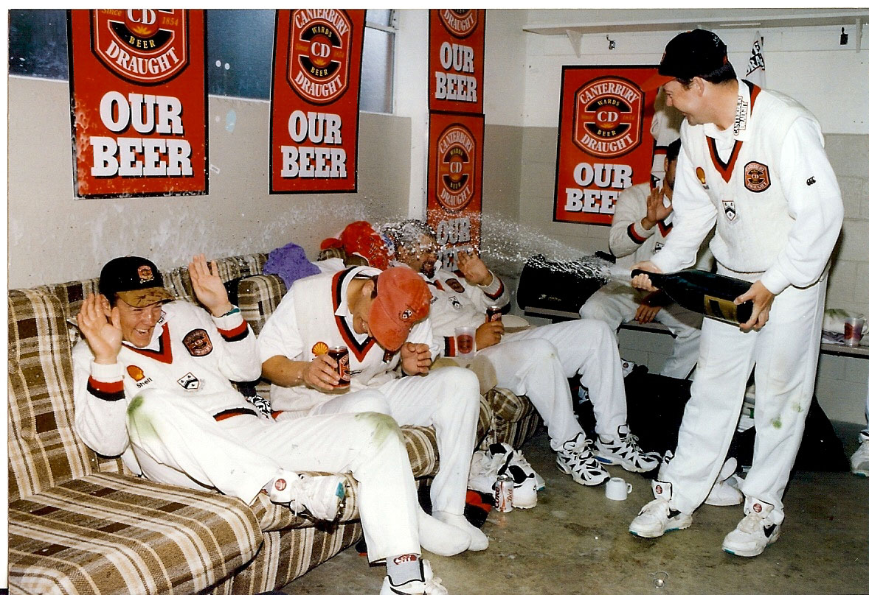

Shell Trophy victory celebrating in the Lancaster Park dressing room 1 April 1997. From left: NJ Astle, WE Wisneski, unknown

Canterbury 777 Otago 189 and 306/8. Match drawn